PRODUCT REQUIREMENTS DOCUMENT

Solution Space

2. Product Concept
The product: a layer that watches a vendor after they're approved, and tells you the moment something important changes.
Companies check vendors hard once, then mostly stop. Bank details change, licences lapse, nobody notices until a payment fails or an audit does. This product builds a starting picture of each vendor and keeps comparing new information against it, flagging only changes that actually matter.
The gap isn't that continuous monitoring doesn't exist, Gatekeeper and KYB players like Vanta already do pieces of it, priced like Gatekeeper's $1,245–$5,295+/month enterprise tiers. It's that nobody combines continuous GST and MSME compliance monitoring, not just security paperwork, with a lightweight, India-compliance-first entry point, at a price a mid-market company can say yes to without a sales call.
Comparing the old way to the new way:

Old way | New way | Closest competitor today
Checked once, trusted forever after | Checked once, watched continuously | Gatekeeper does this, but only inside an enterprise-priced suite.
Security questionnaires repeated for every buyer | One verified profile, reused across buyers | Vanta, Whistic, CyberGRX do this for security only.
No link between vendor status and India rules like GST or the 45-day MSME clock | Vendor status and compliance rules watched together | Tally tracks the 45-day payment clock once you tag a vendor yourself, but doesn't verify Udyam status against source or catch a lapse.

Insight & Conclusion.
Continuous monitoring already exists. What does not exist is continuous GST and MSME compliance monitoring, priced and built for a mid-market Indian company, instead of a security questionnaire wrapped inside an enterprise suite.

3. Primary User Persona
Attribute | Details
Name | Rekha Iyer
Age | 41
Role | CFO, mid-sized logistics company, Pune
Company | ₹350 crore revenue, 400 employees, ~220 vendors. Too big for a spreadsheet, too small for SAP Ariba or Coupa (PS7 tab)
Her biggest goal | No surprises. Sign off on a payment knowing the vendor is still who they say they are, still tax compliant, still owed money on the agreed terms.
Her biggest frustration, every March | Section 43B(h) makes her prove, vendor by vendor, who is a registered Micro or Small Enterprise and who got paid within 45 days. Tally can flag payment aging once someone has manually tagged a vendor as MSME, but nobody checks whether that Udyam number is still valid or notices when a vendor's registration lapses mid-year. Her team ends up verifying it by hand anyway. Miss one, and the unpaid amount gets disallowed as a tax deduction until it is paid. Roughly ₹25–30 lakh a year for every ₹1 crore of unpaid MSME dues, based on typical corporate tax rates, an illustrative estimate, not a quoted external figure.
Her quieter fear | A vendor's bank details changing, with nobody independently checking it. Her current process, an email confirmation, is exactly the weak point fraud exploits. It already happened to an Indore company: fraudsters intercepted an email thread, impersonated a vendor, and redirected a ₹3.72 crore payment to a US bank account. RBI data backs up why she should worry: online payment fraud in India jumped over 400%, and total bank fraud value nearly tripled to ₹36,014 crore in FY25.
Tools she already uses | - Tally, for accounting  - A GST Suvidha Provider, checked manually when something feels off  - A shared Excel sheet, updated by hand for vendor documents and expiry dates

Insight & Conclusion.
Rekha does not want a bigger vendor system. She wants to stop being the last person to find out something changed.

4. Product Flow

4.1 Onboarding Flow
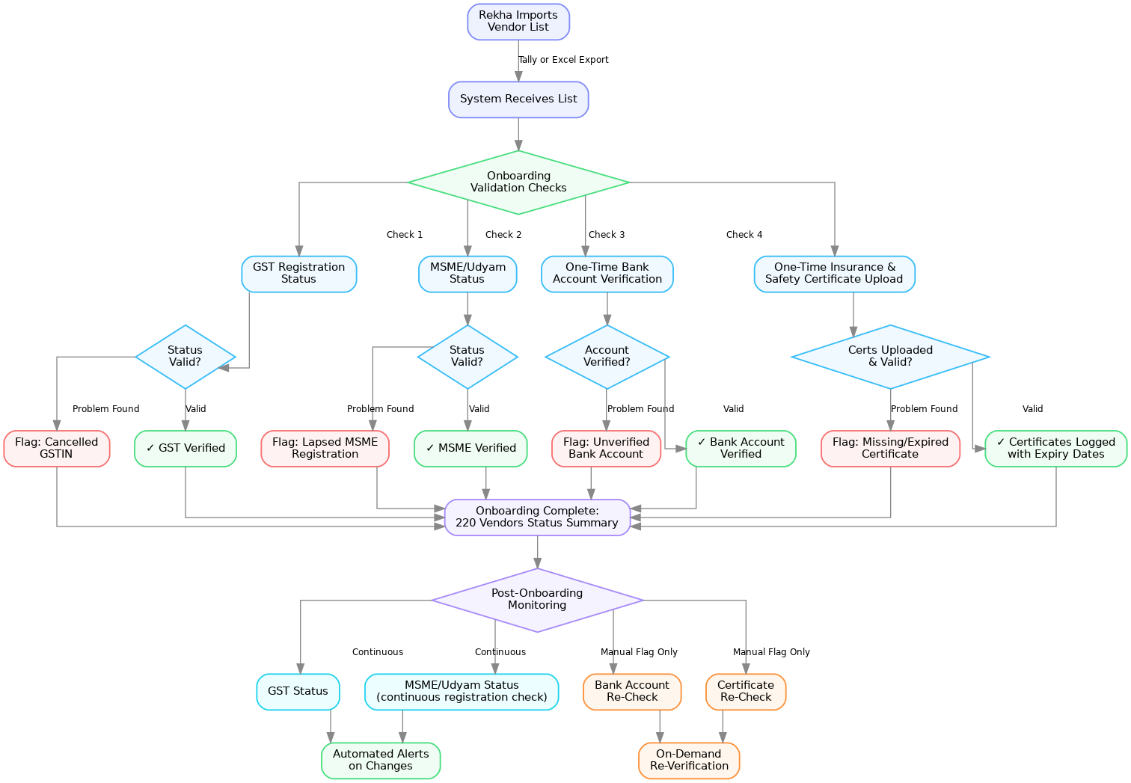
Figure: Onboarding flow, four checks run at connection, then GST and MSME/Udyam status move to continuous monitoring while bank account and certificates are re-checked only on manual flag.
Only GST and MSME status get watched continuously after this point. Bank account and certification checks happen once at onboarding, and again only if Rekha flags a vendor by hand, not polled automatically. Deliberately left out of v1: continuous bank account monitoring and continuous licence or insurance expiry tracking. Real problems, real value later, but watching them the same way GST and MSME are watched would mean building three continuous-monitoring pipelines before proving even one works. She starts with the two attributes that are cheapest to watch continuously, hardest to catch manually, and tied to a real forcing function, the 45-day MSME clock.

4.2 Input Layer
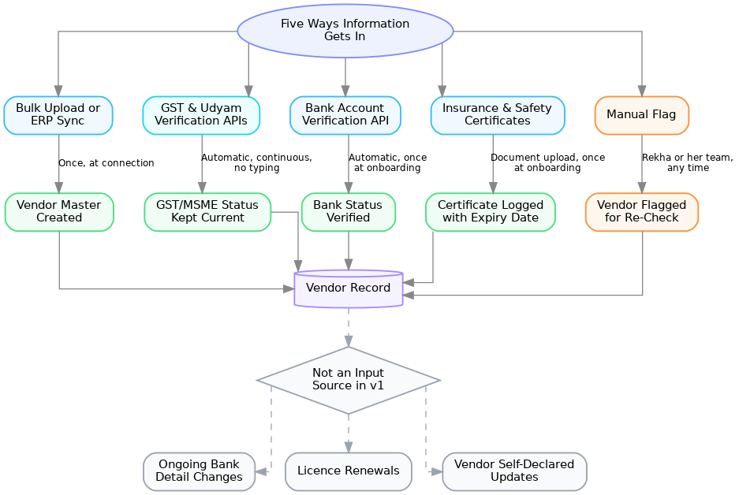
Figure: Five ways information gets in, each with its own cadence, converging into one vendor record. Bank account and certificate checks run once at onboarding, both shown in the diagram above.
Ongoing bank detail changes, licence renewals, and vendor self-declared updates are not continuous input sources in v1. They come later, once GST and MSME monitoring has proven the model works.

4.3 Core Action Flow
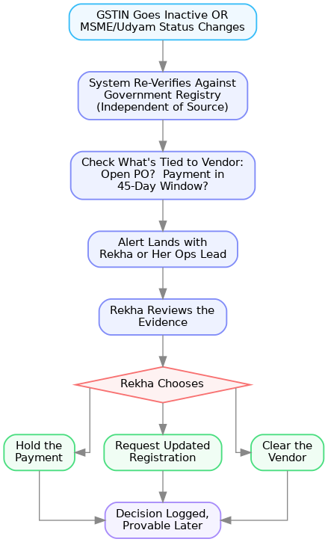
Figure: The repeated action, reviewing a GST or MSME status change and deciding what to do (steps 1–6).
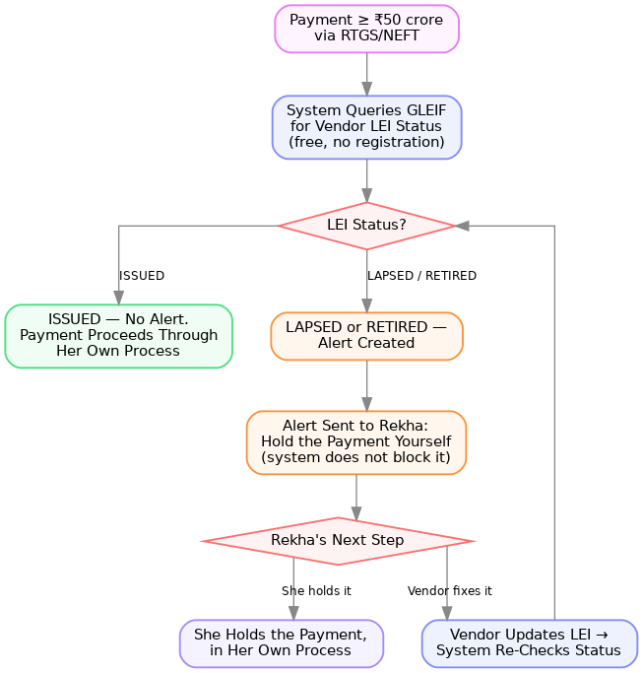
Figure: The conditional LEI check on payments ≥₹50 crore. The system alerts, it does not block the payment itself.
One conditional check, separate from the above: if a payment to any vendor is about to go out via RTGS or NEFT for ₹50 crore or more, the system checks that vendor's LEI status before release. RBI requires a valid LEI on both sides of any such transaction, banks will not process it otherwise. This isn't a continuous monitor like GST or MSME, it only fires when a payment crosses that threshold. Rekha's own vendor payments rarely hit ₹50 crore, but when they do, this is a hard blocker worth catching automatically rather than finding out from the bank. The check itself is free, GLEIF's API needs no registration and returns a clean ISSUED, LAPSED, or RETIRED status.

4.4 Recall or Retrieval Flow
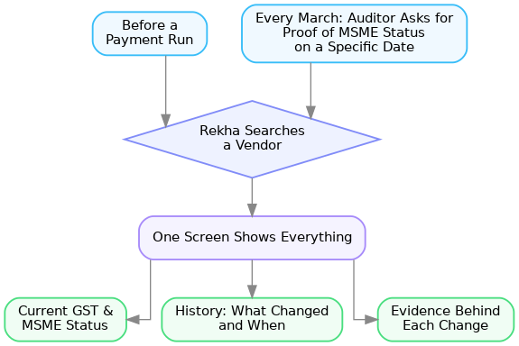
Figure: Two moments trigger the same lookup, one screen answers both, current status, change history, and evidence.

4.5 Nudge and Follow-Up Flow
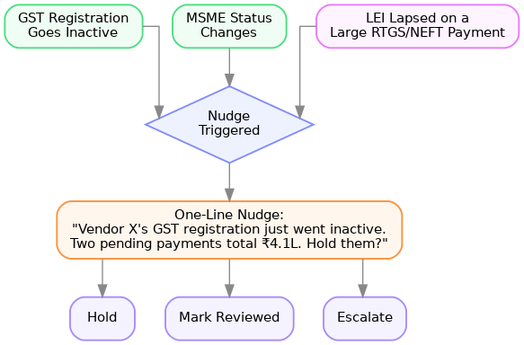
Figure: Three triggers feed one nudge, a one-line message stating what changed and what’s at stake, with a one-tap hold, review, or escalate action.
Sources:
- Vendor risk concentration / prioritizing high-risk vendors first
- Verification speed proof point
- RBI LEI mandate for RTGS/NEFT transactions ≥₹50 crore
- GLEIF free LEI look-up API, ISSUED/LAPSED/RETIRED status
- Alert fatigue: 67% of security alerts eventually ignored, orgs average ~2,992 alerts/day with ~83% false positives
- Alert fatigue, consumer product context: 64% of users delete an app after 5+ notifications a week; 3-5 a day is the practical ceiling before people start disabling alerts
Insight & Conclusion.
Two attributes, watched well, beat five attributes watched half-heartedly. The LEI check earns its place anyway, because it's free, legally required, and only shows up when it actually matters. And with alert fatigue setting in after as few as 3-5 notifications a day in other contexts, starting narrow isn't just an MVP compromise, it's what keeps Rekha actually reading the alerts instead of muting them.

5. Workflow Mapping - Before and After
The table below walks through Rekha's normal cycle: onboarding vendors, Friday payment batches, and the annual Section 43B(h) audit.
Step | Before your product | After your product
Onboarding a new vendor | Bank details come by email or on a PO. Rekha's team takes them at face value, no independent check. | Bank account gets verified once, automatically, before the vendor is added to the payment list. Nothing re-checks it after that unless she flags the vendor by hand.
Friday payment batch | Finance approves payments based on the vendor master as it stood at onboarding, whenever that was | Every vendor on the list already shows current GST and MSME status, no manual check needed
A vendor's GST lapses or their MSME status changes | Nobody finds out, unless the vendor happens to mention it | Rekha gets a nudge the same day, with pending payments flagged automatically
March, tax audit season | Her team manually pulls Udyam certificates and payment dates for ~220 vendors, cross-checking by hand | The Clause 22 evidence has been building all year. She exports it, she doesn't assemble it
A vendor turns out to be non-compliant | Found out after the fact, sometimes from the auditor, sometimes from a blocked deduction | Caught before the payment goes out, not after

The biggest saving isn't time, it's exposure. At an illustrative ₹25–30 lakh per crore of unpaid MSME dues if she misses one (based on typical corporate tax rates, not a quoted external figure), catching it before the payment clears is worth more than catching it faster afterward.
Insight & Conclusion.
The real saving isn't speed, it's moving the moment of discovery from after the damage to before it.

6. Platform Architecture
Six parts, each doing one job:
Component | Job | Built With
Vendor Master Connector | Pulls in the vendor list from whatever Rekha already uses, Tally export, Excel, ERP, and normalizes it into one format. | Import endpoint + CSV/XLSX parser + column-mapping UI
Verification Engine | Calls out to GST via a GSP API, Sandbox by Quicko, with Masters India as a fallback if ERP coverage needs it, Udyam, and GLEIF on a schedule for continuous checks, plus a one-time bank account API call at onboarding. Insurance and certification documents are collected and logged separately, not pulled automatically, since no single government API covers every certificate type. | Scheduled jobs invoking provider adapters (Sandbox, Deepvue, GLEIF, Eko) behind one common interface
Change Detector | Compares each new check against the last known baseline for that vendor, flags what's different. | Compares each new result against the vendor's prior check of the same type
Impact Scorer | Checks what's tied to that vendor, an open PO, a payment inside the 45-day window, a transaction size that crosses the LEI threshold, to decide if the change is worth an alert. | Rule logic joining the changed vendor against open payments/POs and the LEI threshold
Alert & Decision Layer | Routes the alert to the right person, captures what they decided. | Alert inbox + one-tap hold/reviewed/escalate + email notification
Evidence Log | Stores every check, every change, and every decision, so it can be pulled up instantly in March. | Append-only log, written on every check, change, and decision
How they connect:
Step | Feeds into
Connector | Verification Engine, on a schedule
Verification Engine | Change Detector, with each check's result
Change Detector | Impact Scorer, when it flags something as different
Impact Scorer | Alert & Decision Layer, when the change actually matters
Every step | Evidence Log, always, whether or not it triggers an alert
Hard limits — rules, laws, and technology constraints we cannot get around:
Constraint | Why it's a hard limit
GST/Udyam checks aren't free or instant | GSP (GST Suvidha Provider) APIs charge per call, as low as ₹0.72 (PS7 tab), and the government doesn't push notifications when a status changes. The system has to poll on a schedule rather than react in real time. Checking 220 vendors daily is cheap; checking every minute isn't, and wouldn't catch anything faster anyway, since the underlying registry doesn't update that often.
LEI check stays conditional, permanently | Free through GLEIF, but only applies to a narrow slice of transactions, RTGS/NEFT payments ₹50 crore and above. That's a rule set by the RBI mandate itself, not a v1 limitation — it never becomes a continuous check.
DPDP Act sets the data-handling boundary | Most of what this product touches is business data, not personal data, so it sits mostly outside the core of India's DPDP Act. But any individual proprietor's PAN, or a contact person's phone number, still counts as personal data the moment it's pulled in. Consent and purpose-limitation need to be built in from day one, not added later.
Source-format normalization is ongoing, not one-time | The Connector has to normalize very different source formats — a Tally export looks nothing like an SAP export. That's ongoing maintenance every time a new ERP gets added, not a one-time build.
Sources:
- GSP API pricing (~₹0.72/check) — workbook, PS7 – India Mid-Market tab
- RBI LEI mandate, ₹50 crore RTGS/NEFT threshold
- GLEIF free API
- DPDP Act 2023 scope and applicability
- Sandbox by Quicko GST API, self-serve pay-per-call fit — Masters India as ERP-coverage fallback
Insight & Conclusion.
Government registries don't push updates, they have to be polled, and that shapes everything else. Alerts are only ever as fresh as the last check. The design leans into that honestly, setting polling cadence around cost and how fast status actually changes, instead of promising real-time detection it can't deliver.

7. Moonshot
The idea | Once a vendor's GST and MSME status have been watched over time, and their bank account and certifications verified once at onboarding, by one buyer, that history shouldn't have to be rebuilt from scratch by the next buyer. A vendor carries a verified trust profile from company to company. Each buyer still makes its own call, but the verification itself becomes reusable, not repeated.
Where it could lead | Supplier due diligence, insurance, working-capital lending, marketplaces, anywhere someone needs to know if a business is who it says it is
What it solves beyond v1 | V1 saves Rekha from being surprised by her own vendors. This saves the vendor from proving the same thing to every buyer they sell to, turning a cost into something they earn once and spend many times.
Why it's not ready yet | Needs both sides to show up: vendors with something worth carrying, and multiple buyers willing to trust someone else's verification. Building it before v1 proves itself means competing head-on with well-funded players already circling this space.
Who's already circling it | Vanta, $4.15B valuation. Drata, $250M acquisition of SafeBase. Whistic, CyberGRX, OneTrust Vendorpedia. All security-questionnaire-only, none cover banking, tax, or MSME status.
What has to happen first | A real base of verified GST and MSME history, plus bank and certification verification, from actual usage, not a guess at what vendors would carry if asked.
Sources:
- Vanta $150M Series D, $4.15B valuation
- Drata acquires SafeBase, $250M
- Whistic, CyberGRX, OneTrust Vendorpedia
Insight & Conclusion.
The moonshot isn't a bigger version of the same product, it's the point where the product stops being Rekha's tool and starts being the vendor's asset.

8. User Stories
Story | Done when | Fixes
Getting started
As a finance head, I want to connect my existing vendor list without re-typing anything, so that I can see problems in my current vendor base on day one. | GST and MSME checks complete on 100% of uploaded vendors within minutes of connecting. | No single system keeps the vendor record current after onboarding.
Daily use
As a finance head, I want to know the same day a vendor's GST registration goes inactive, so that I can hold pending payments before they go out. | Alert fires within one polling cycle, shows the affected payment amount. | Teams keep making decisions on information that's no longer true.
As a finance head, I want to see a vendor's current status and full history on one screen, so that I don't dig through email before a payment run. | Search returns status, timeline, and evidence in seconds. | Vendor information scattered across systems, nobody owns the full picture.
As a finance head, I want to be alerted immediately if a vendor's LEI has lapsed before a large RTGS/NEFT payment goes out, so that I can hold it myself before the bank flags it. | Alert fires before the payment window closes, showing the affected amount; I can hold it in one tap. | Payments continuing to an entity that's no longer compliant.
Getting ready for audit
As a finance head, I want a ready-to-export record of every vendor's MSME status and payment dates through the year, so that I'm not assembling Form 3CD by hand every March. | Export produces Clause 22-ready evidence with no manual reconciliation. | Audit prep taking weeks, done from memory and scattered documents.
As a finance head, I want every alert and the decision made on it logged automatically, so that I have proof if a vendor issue is ever questioned later. | Every detected change and the action taken is stored and retrievable by vendor and date. | No record of what changed or what anyone did about it.

Insight & Conclusion.
The same-day GST alert is the one that matters most. If that fails silently, everything else in this product is just a nicer-looking version of the manual process it's supposed to replace.

9. MVP Scope
In one sentence: the first version connects a company's existing vendor list, checks GST and MSME status continuously, verifies bank account and insurance/certification details once at onboarding, flags a lapsed LEI before a large RTGS/NEFT payment goes out, and tells finance the same day something changes that could affect a payment or a tax deduction.
Must-have feature | Hypothesis being tested | What would prove it wrong
Vendor list connector (bulk upload / ERP sync) | Companies can connect an existing vendor list without a heavy IT project. | Most pilot customers need their own IT team involved, or it takes more than a few days to get vendors connected.
GST status check, run continuously | GST status changes often enough on a live vendor base to justify watching it, not just checking once. Real cancellation activity backs this: 1.63 lakh GSTINs cancelled by authorities in a single two-month window nationally. | Almost none of a pilot customer's vendors show any GST status change over a 90-day test window.
MSME/Udyam status check, run continuously | This surfaces a lapsed or changed Udyam registration, something payment-aging tools like Tally don’t check, not just a missed payment date. | Pilot customers already knew about every flagged MSME issue before the alert. No new information, no new value.
One-time bank account and insurance/certification verification at onboarding | Bank-detail fraud and expired coverage are catchable at the point of entry, before a vendor is ever paid, without needing continuous monitoring. | Verified vendors still turn out to have mismatched bank details or lapsed certificates that pilots would have caught anyway.
Same-day change alert, shows payment impact | Getting the alert same-day changes what finance actually does, not just what they know. | Alerts get acknowledged but the payment goes out anyway most of the time.
Evidence log, Form 3CD-ready export | This meaningfully cuts audit prep time in March (PS7 tab). | Audit prep time doesn't measurably drop for pilot customers using the export versus their old manual process.
LEI check on large RTGS/NEFT payments | This edge case is common enough, worth building now. | Zero pilot customers ever have a transaction cross ₹50 crore during the pilot window. If so, defer this to a later phase.

Sources:
- GST cancellation frequency, 1.63 lakh in two months
- LEI threshold and check mechanics
- Tally MSME payment-aging tracking, does not verify Udyam status — manual Udyam verification remains a separate step
Insight & Conclusion.
If GST and MSME status barely ever change, the whole idea collapses into a one-time check, no better than what onboarding already does. That's the hypothesis worth testing first, before anything else gets built.

10. What We Left Out and Why
Left out for now | Why not now | When to revisit
Continuous bank account change monitoring | Highest fraud severity of anything on the list, but needs its own verification pipeline and its own trust model. Adding it alongside GST/MSME in v1 means testing three hypotheses at once instead of one. | Fast-follow, right after the GST/MSME hypothesis (Section 9) is proven.
Continuous licence and insurance expiry tracking | No single government API covers this, each licence type needs its own integration. Building a generic checker now risks integrating licence types that turn out not to matter. | Once a pilot customer's industry makes one specific licence type clearly worth the build.
Vendor self-declaration portal | Adds a whole vendor-facing surface, support, UX, adoption risk, before we know if buyer-side monitoring alone already delivers the value. | After v1 proves buyers value the alerts. Only then is it worth asking vendors to participate directly.
Portable trust profile across buyers | Needs a real base of verified history and multiple buyers willing to trust each other's verification, a two-sided cold start (Section 7). | Long-term, once enough verified history exists from real usage.
Continuous LEI status monitoring | V1 only checks LEI at the moment of a qualifying large payment, it doesn't watch for a lapse in between on purpose (Section 4.5). | Once ₹50 crore+ transactions are common enough among customers to justify watching continuously instead of checking at payment time.
Ownership and control change monitoring | A real risk named in the original problem statement (FINALLLLL CONVERGED PS tab), but no verification source was scoped or costed for v1. | Once the GST/MSME hypothesis is validated and there's budget to find a data source for this.

Insight & Conclusion.
The bet being made is that bank-detail fraud won't hit a pilot customer through a change made after onboarding, since a bad account from day one is now caught by the one-time check. That's the one omission with the sharpest downside if the bet is wrong.

11. Success Metrics
Two kinds of numbers matter here: leading metrics that show early whether people are actually using it, and lagging metrics that prove it changed a real decision or saved real time.
North Star Metric: Payments the finance head holds herself, prompted by an alert.
The system never holds a payment itself, it alerts, and she decides in one tap (Section 4.5). Every other metric on this page is either a precursor to this happening, a vendor connected, an alert actioned within 24 hours, or a downstream consequence of it, audit prep time saved, pilot-to-paid intent. This is the one number that proves the product is doing what Section 5 promises: moving the moment of discovery from after the damage to before it. Same target and kill signal as the lagging metric below: at least 1 payment held or rerouted per customer in 30 days because she chose to; the signal fails if alerts get acknowledged but the payment goes out anyway, every time.

Leading metrics
Metric | 30-day target | Kill signal
Vendor list connected without IT | 90%+ of a pilot's vendors connected within 3 days of signup | Fewer than 50% connected within 2 weeks, or IT has to get involved
Time to first value | First vendor-risk view (GST, MSME, bank, certificate issues) shown within 15 minutes of connecting | Takes longer than a day for most customers to see any value
Real GST/MSME status changes detected | At least 1 status change (cancelled GSTIN, lapsed Udyam) per 100 vendors within 30 days | Zero status changes detected across all pilot vendors, the core "watch continuously" hypothesis fails
Alerts actioned within 24 hours | Alert fires within one polling cycle; 80%+ get a one-tap action (hold, reviewed, or escalate) within 24 hours | Fewer than 30% actioned within 48 hours, an early sign of alert fatigue
Alert precision (real issue, not noise) | 90%+ of alerts confirmed by the customer as a genuine issue, not dismissed as false or irrelevant | Below 60% precision, the same alert-fatigue risk named in Section 4.5

Lagging metrics
Metric | 30-day target | Kill signal
Payments the finance head holds herself, prompted by an alert | At least 1 payment held or rerouted per customer in 30 days, because she chose to hold it after seeing an alert, not an automatic system hold | Alerts get acknowledged, but the payment goes out anyway, every time
Bank or certificate issues caught at onboarding | At least 1 mismatched bank account or expired certificate caught before first payment, per customer | Zero issues found across all pilots, the one-time check isn't earning its build cost
Audit prep time saved | Self-reported Form 3CD prep time drops 30%+ versus the prior year, for customers reaching audit cycle | No measurable time reduction reported
Pilot-to-paid intent | 50%+ of pilot customers ask to move to a paid contract by day 30 | Fewer than 20% show any conversion intent
Would be "very disappointed" without it | 40%+ of pilot users say "very disappointed" if the product went away, the Sean Ellis 40% test, a widely used product-market-fit benchmark | Below 20%, a weak product-market-fit signal

Insight & Conclusion.
Real GST/MSME status changes detected matters most. It is the leading signal underneath every other number here; if it reads zero, nothing downstream, held payments, saved audit time, or renewal intent, has a chance to happen.

12. Implementation Plan
The first testable pilot ships in five phases, each one only unlocking once the phase before it works. This is a website, not a native mobile app, built on Next.js and Supabase. The full phase-by-phase build breakdown, dependencies, and acceptance criteria live in the companion Implementation Plan document; the technical architecture, data model, and API contracts behind it are in the companion Engineering Requirements Document (ERD).
Phase | What gets built | Why this order
1 | Vendor list connector + continuous GST/MSME checks | The core hypothesis from Section 9, if this doesn't hold, nothing else is worth building
2 | One-time bank account + insurance/certificate verification at onboarding | Same connector, adds the two onboarding-only checks
3 | Same-day alert with one-tap action (hold, reviewed, escalate) | Turns a detected change into something Rekha can act on; runs in parallel with Phase 2
4 | Evidence log / Form 3CD export + LEI check on large payments | Lower urgency, only matters at audit time or above ₹50 crore
5 | Pilot rollout + metrics instrumentation | Real customers, tracking Section 11's metrics against their kill signals

What could slow this down: not API approval delays broadly. GLEIF’s LEI look-up is free with no registration, and Sandbox’s GST API is self-serve with same-day signup. The one real dependency is Udyam verification, where the established vendors (HyperVerge, AuthBridge) require a sales contract before API access. Starting with Deepvue’s self-serve, pay-per-call option, or Eko’s sandbox credentials for bank verification, avoids that sales-cycle delay in Phase 1 and Phase 2.
Build principle: every third-party API in v1 runs on a free tier or free trial first, GLEIF (free), Sandbox (pay-per-call self-serve), Eko (sandbox credentials, no paperwork to start), Deepvue (free trial on real data). If a capability has no free or trial path by the time it's needed, that phase ships against mock data instead of signing a paid contract before the hypothesis is proven.
Insight & Conclusion.
Phase 1 is the riskiest part, it carries the core hypothesis and the only live API dependency the plan leans on early. If Udyam verification ends up running on mock data because no free-trial path holds up, the pilot would be testing a synthetic signal instead of a real one, which defeats the point of testing it at all.

13. Trade-offs and Limitations
Three honest limits, on purpose, not by accident.
What it will not solve
- Fraud that never touches GST, MSME, bank, or certification status, such as invoice duplication or internal collusion. The product watches vendor-side compliance signals, not internal control failures.
- Ownership or control changes at a vendor. A real risk named in the original problem statement, but no verification source was scoped or costed for v1 (Section 10).
- Payment enforcement. The system alerts and lets Rekha's team hold a payment; it does not intercept or block anything on the bank's own rail (Section 8).
- Vendor-side transparency. Vendors are not in the loop; nothing here lets a vendor see or contest their own status, or self-declare a change (Section 10).
Trade-offs made on purpose
- Two attributes watched continuously, GST and MSME, instead of five, to prove the core hypothesis before building three more monitoring pipelines (Section 9, Section 10).
- Bank account and certification verified once at onboarding, not continuously. Cheaper to build, but a bank-detail change made after onboarding is not caught until someone flags it by hand, the sharpest-downside bet in this whole plan (Section 10).
- LEI checked only at the moment of a qualifying large payment, not watched continuously. Accepted because it is free, legally required, and rare enough not to justify a full pipeline yet (Section 4.5).
Outside dependencies
- A GSP API for GST status, Sandbox by Quicko to start, with Masters India as an ERP-coverage fallback. Accuracy and uptime depend on the provider, not just the government registry directly (Section 6).
- GLEIF's free LEI look-up API (Section 4.5).
- A Udyam/KYB verification vendor, Deepvue to start, since there is no direct government API for automated Udyam verification (Section 12).
- Eko's bank account verification API (Section 4.1).
- The customer's own vendor list quality. A messy or duplicated upload degrades the "within minutes" onboarding promise (Section 4.1).
- The customer's existing ERP or Tally instance, for the initial vendor list pull. This product does not replace Tally's own payment-aging tracking, it fills the specific gap Tally leaves, Udyam verification (Section 2, Section 9).
Insight & Conclusion.
Verifying the bank account only once, at onboarding, is the trade-off I'm least comfortable with. It's made anyway because testing three continuous-monitoring hypotheses at once, instead of proving one first, would have delayed everything else this plan depends on.

